RHS Coding Club

Put together a small app that allows the developer to work with databases and visual development using the development language C# (C-Sharp).

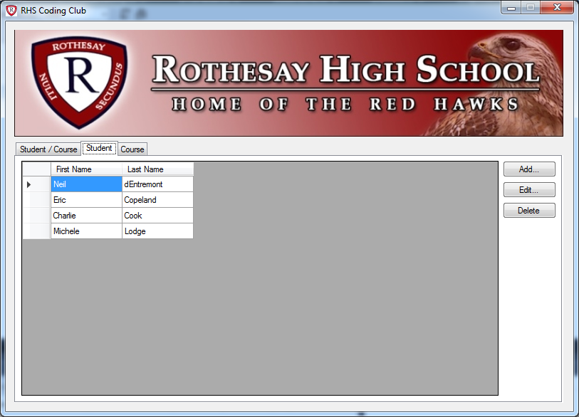

In order to put an application together, a good place to start is from the ground up, so we’ll begin with the data and database.

Database

The database we are using is SQL Server. SQL Server is a relational database. A relational database management system (RDBMS) is a database management system (DBMS) that is based on the relational model as invented by E. F. Codd, of IBM's San Jose Research Laboratory. Many popular databases currently in use are based on the relational database model.

RDBMSs are a common choice for the storage of information in new databases used for financial records, manufacturing and logistical information, personnel data, and other applications since the 1980s. Relational databases have often replaced legacy hierarchical databases and network databases because they are easier to understand and use. However, relational databases have been challenged by object databases, which were introduced in an attempt to address the object-relational impedance mismatch in relational databases, and XML databases.

<http://en.wikipedia.org/wiki/Relational_database_management_system>

W3Schools.com is a great site for SQL documentation.

<http://www.w3schools.com/sql/>

**Tables**

We created tables last class. In this class use the SQL provided to regenerate your table and level set with the rest of the class.

**Inserting Data**

Use the SQL provided to load data into your Student and Course tables

**Querying Data**

Using the W3Schools site, research how to select (query) data.

**Exercise:**

* Select all Student records.
  + Hint: W3Schools SQL SELECT, SELECT *
* Select the first name and last name of all Student records.
  + Hint: W3Schools SQL SELECT
* Select (and combine) the first name and last name of all Student records.
  + Hint: W3Schools SQL SELECT, field1 + field2
* Select Student records whose last name begins with ‘C’.
  + Hint: W3Schools SQL LIKE
* Select all Course records.
* Select all Computer Science courses.
* Select all 112 courses.
* Select all Computer Science AND 112 courses.
  + Hint: W3Schools SQL SELECT, AND
* Select all Computer Science OR 112 courses.
  + Hint: W3Schools SQL SELECT, OR

**Joining Tables**

Using the W3Schools site, research how to do joins. SQL Joins

**Exercise**

Using the StudentCourse table and joining to the Student and Course table, create a Select query to return the following data. To create column names like below, see **SQL Aliases**.

|  |  |  |
| --- | --- | --- |
| Student Name | Course (Level) | Mark |

For Example,

|  |  |  |
| --- | --- | --- |
| Neil dEntremont | Computer Science (112) | 95 |

**Stored Procedures**

<http://databases.about.com/od/sqlserver/a/storedprocedure.htm>

<https://www.youtube.com/watch?v=fjNsRV4zLdc> – by WiseOwl (there are my other good videos)

<http://stackoverflow.com/questions/459457/what-is-a-stored-procedure> - StackOverflow is another great technical resource.

**Exercise**

* Create a stored procedure to…
  + Return all Student records.
  + Insert a Student record by taking first name and last name as parameters.
  + Update a Student record by taking id, first name and last name as parameters.